Buscar versión de Chrome correspondiente

<https://chromedriver.storage.googleapis.com/2.36/notes.txt>

Note - To check the compatibility of chrome browser and chrome driver exe use this link - https://chromedriver.storage.googleap...

Here replace the x.xx with the version of chrome driver, example - <https://chromedriver.storage.googleap>...

Today we will learn...

How to add Chrome Driver

Run a test on Chrome browser

Step 1 :

Download ChromeDriver

Step 2 :

Add ChromeDriver in Eclipse

Step 3 :

Add script in Eclipse (IDE)

Verificar que versión de Chrome tengo en la maquina – descargar el driver Chrome – crear carpeta y arrastrar el driver -

Llamar al driver: path

Thread.sleep(3000) : retarda 3 segundos

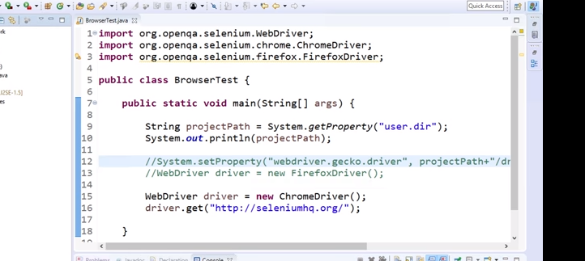

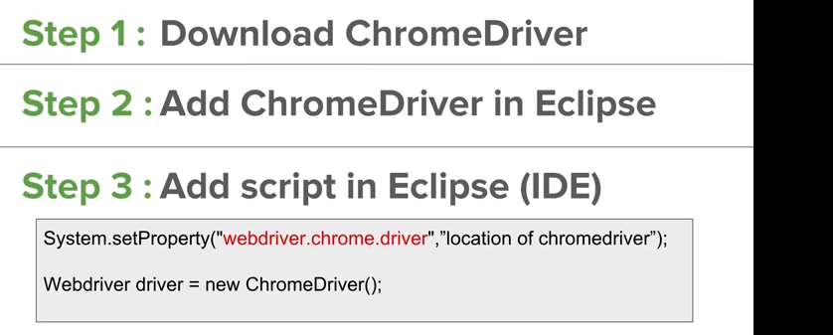

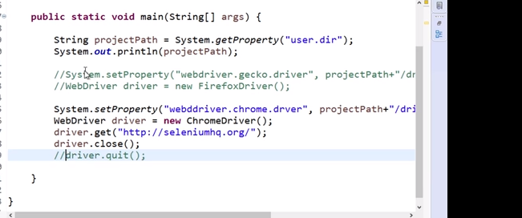

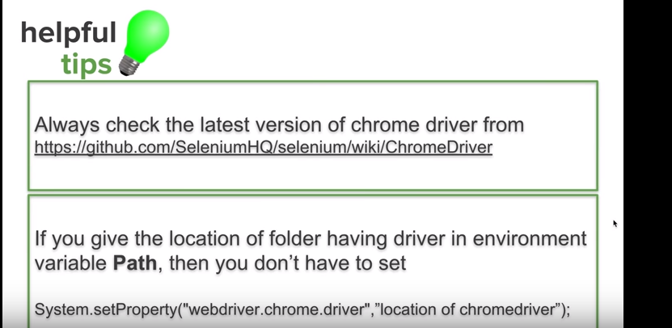

Comprobar versión Chrome: configuración –acerca de google

<https://github.com/SeleniumHQ/selenium/wiki/ChromeDriver>

generar variable entorno: (driver)

# Codigo

**package** Pack;

**import** org.openqa.selenium.WebDriver;

**import** org.openqa.selenium.chrome.ChromeDriver;

**import** org.openqa.selenium.firefox.FirefoxDriver;

**public** **class** PruebaMozilla {

**public** **static** **void** main(String[] args) {

String projectPath=System.*getProperty*("user.dir");

System.***out***.println("projectPath "+projectPath);//si no trae nada es null (no existe)

//System.setProperty("webdriver.gecko.driver",projectPath+"\\Driver\\Firefox\\geckodriver.exe");

//System.setProperty("webdriver.gecko.driver","C:\\Users\\Valentino Falcucci\\Desktop\\semana 20-25\\Raghav\\AutomationStep\\Driver\\Firefox\\geckodriver.exe");

//WebDriver driver=new FirefoxDriver();

// System.setProperty("webdriver.chrome.driver",projectPath+"\\Driver\\Chrome\\chromedriver.exe");

System.*setProperty*("webdriver.chrome.driver","C:\\Users\\Valentino Falcucci\\Desktop\\semana 20-25\\Raghav\\AutomationStep\\Driver\\Chrome\\chromedriver.exe");

WebDriver driver=**new** ChromeDriver();

driver.get("https://www.seleniumhq.org/");

**try** {

Thread.*sleep*(3000);

} **catch** (InterruptedException e) {

e.printStackTrace();

}

driver.close();

}//clase

}//Espacio